**CHAPTER 6**

**CONCLUSION**

The website provides a rich user interface to allow the users to have a great user experience. For implementing this system, PHP, HTML, CSS, JavaScript and MySql are used.

The system comprises of following features:

* User signup/ login.
* Commenting, messaging feature.
* Showing the posts by recent posts, most viewed and by categories.

**SCOPE OF ENHANCEMENT**

There are also few features which can be integrated with the system to make it more flexible.

Below list shows the future points to be considered:

* Implementing an option to share the posts on any social media.
* Making it more versatile, so that registered user can also share their posts.
* Notification for user on post posted by admin.

**REFERENCES**

[1] www.w3schools.com

[2] developer.mozilla.org

[3] www.stackoverflow.com

[4] www.coursera.org

[5] www.youtube.com

[6] www.wikipedia.org

[7] [www.udemy.com](http://www.udemy.com)

**APPENDIX A: SNAPSHOTS**

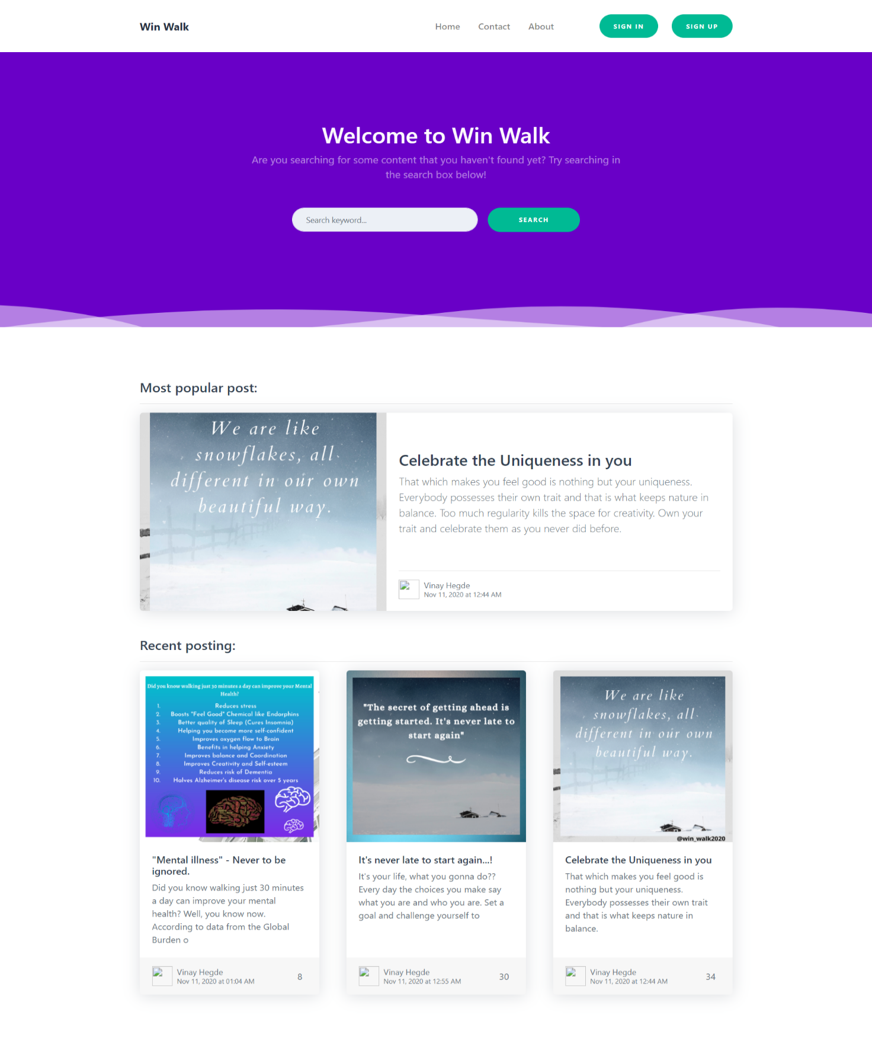

Fig 6.1 Home page - part 1

Win-Walk

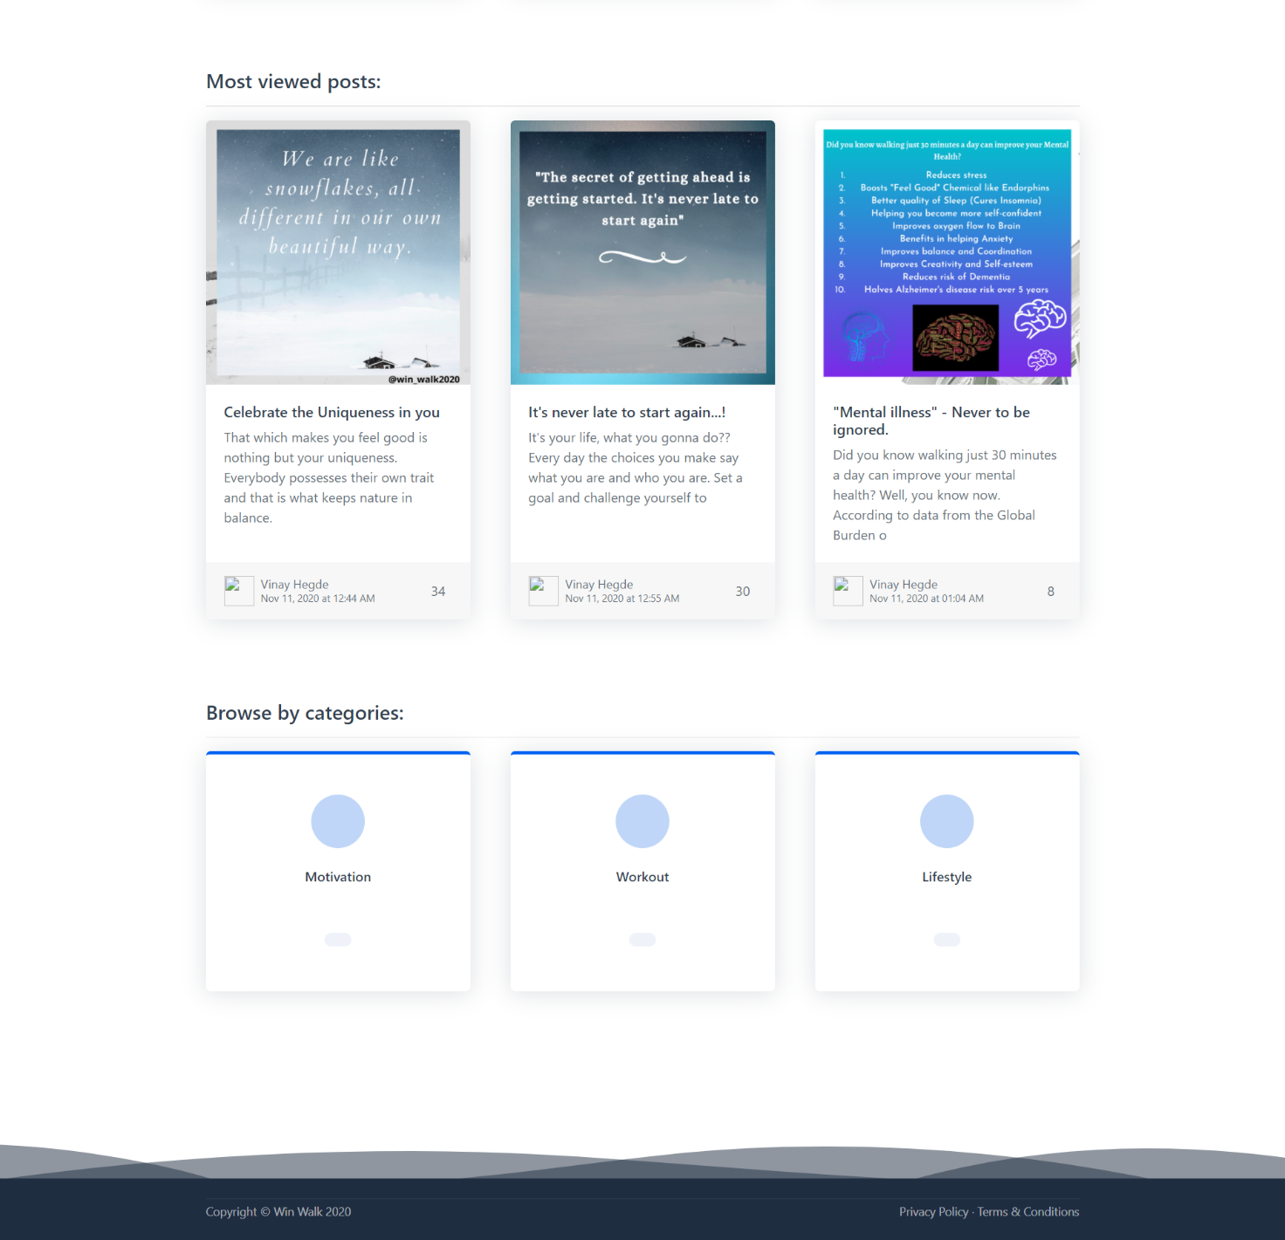

Fig 6.2 Home page - part 2

Win-Walk

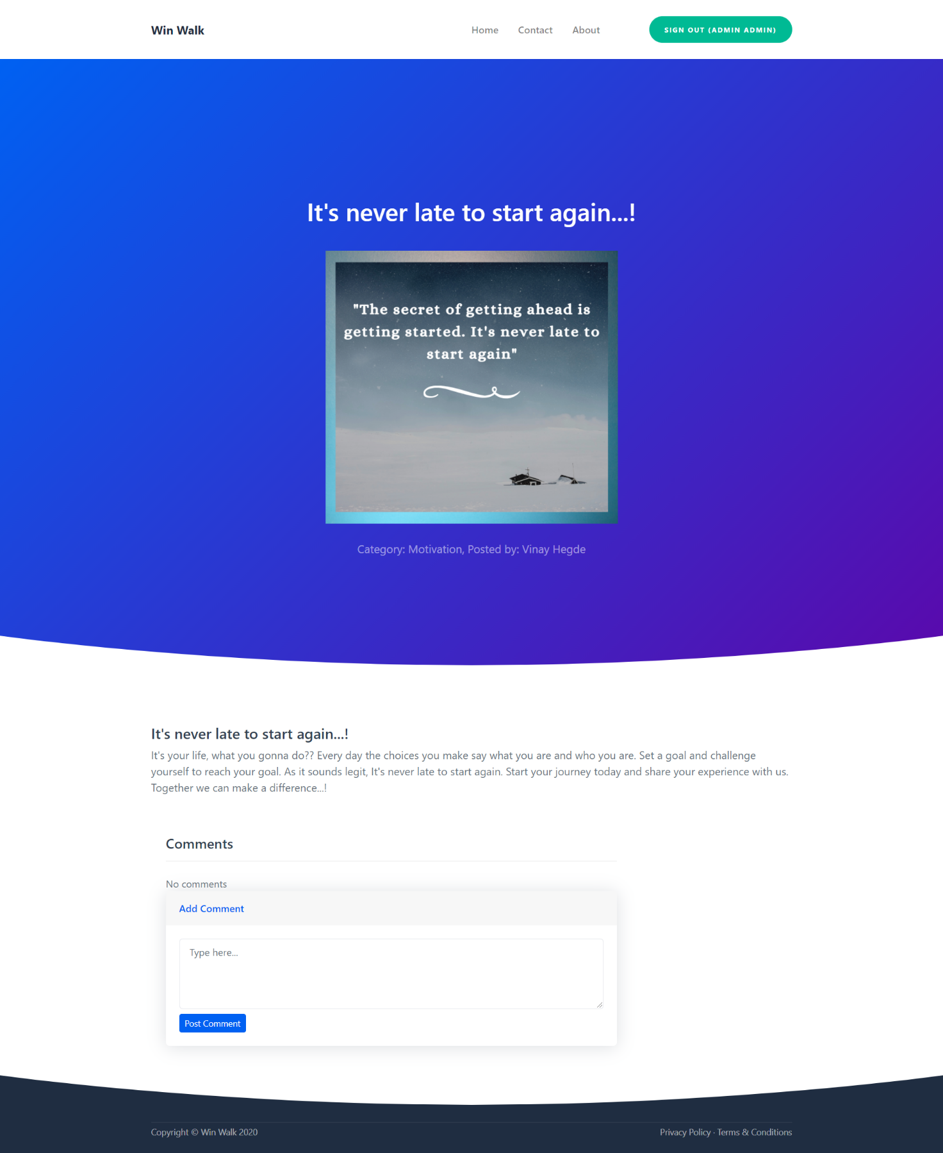

Fig 6.3 Post page

Win-Walk

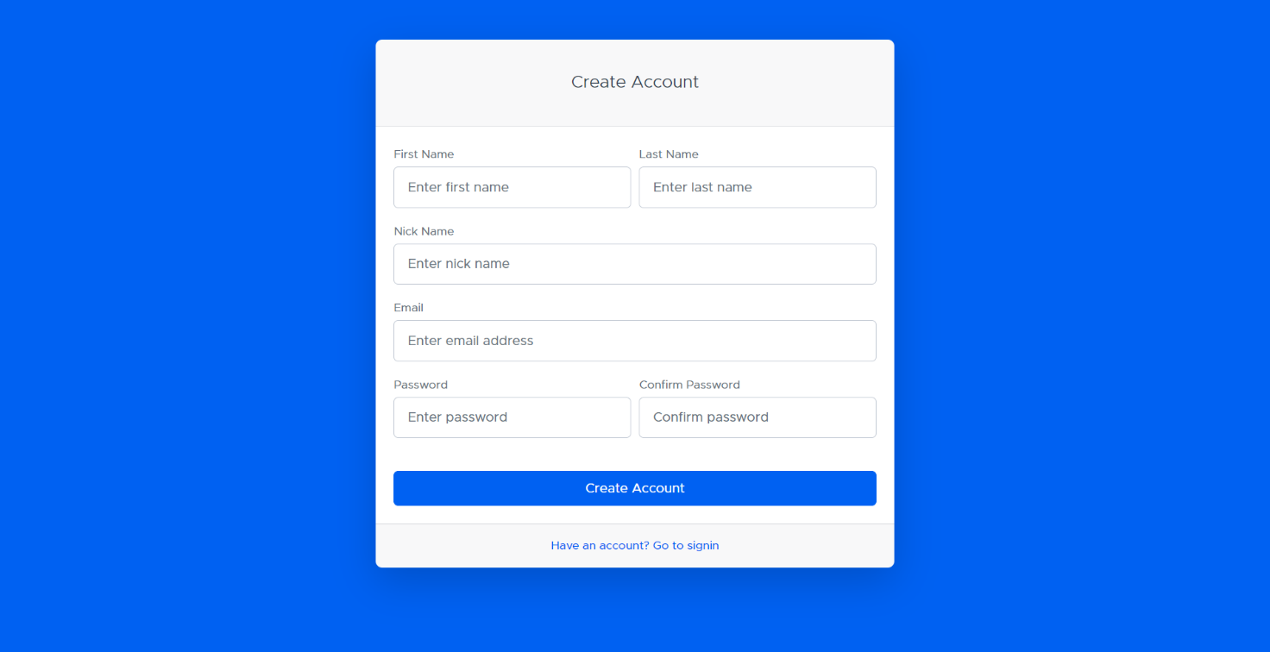 Fig 6.4 User Sign-up page

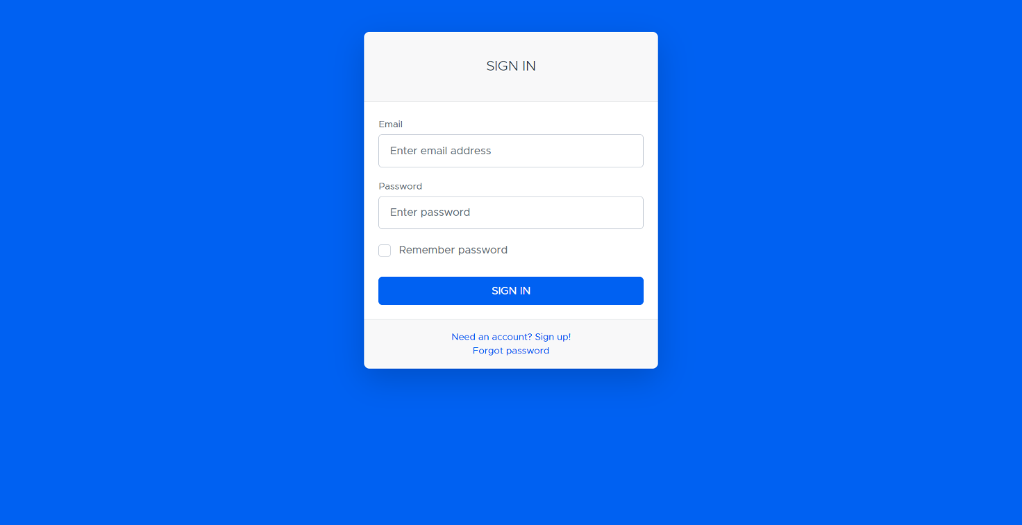 Fig 6.5 User Sign-in page

Win-Walk

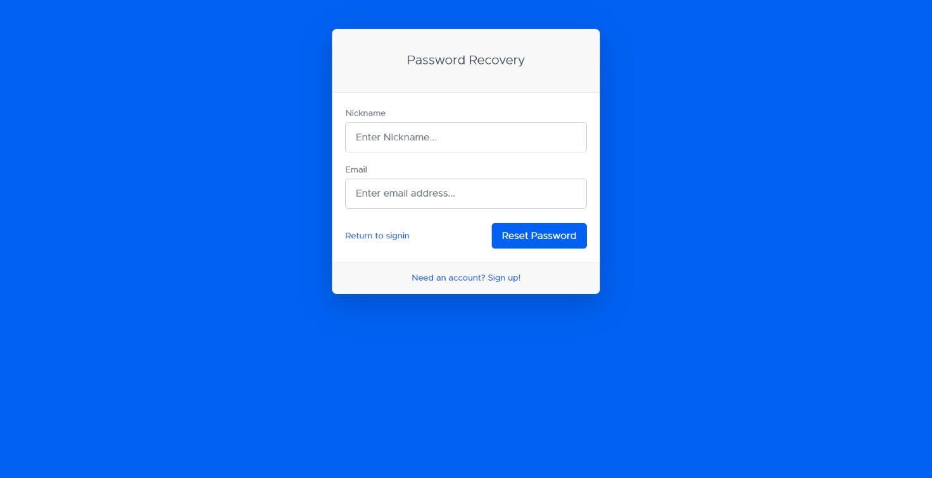 Fig 6.5 Forgot password page 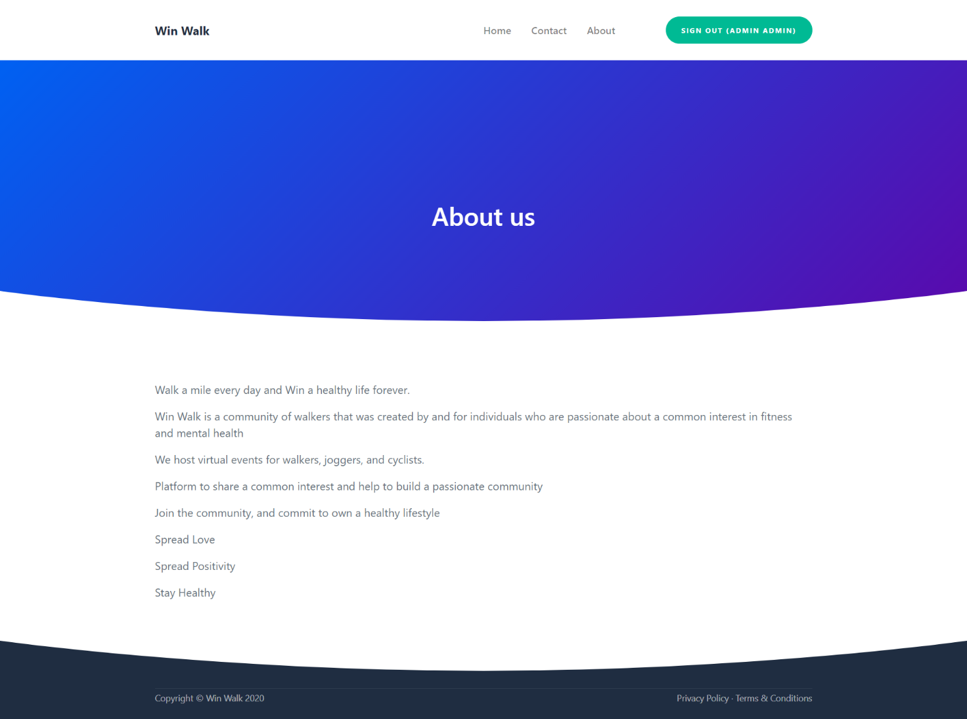 Fig 6.6 About us page

Win-Walk

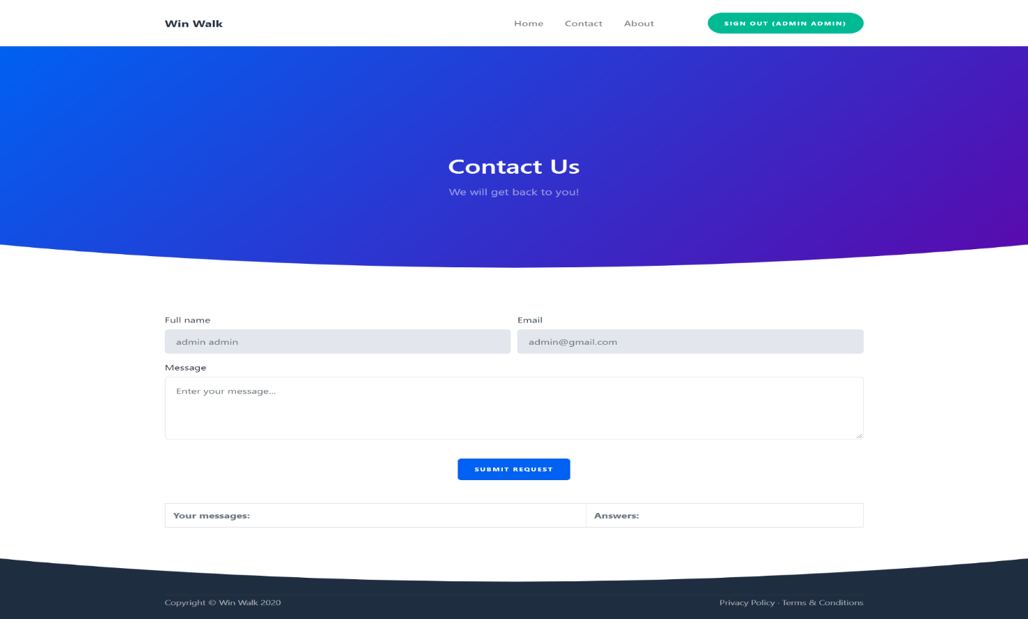

Fig 6.7 Contact us page

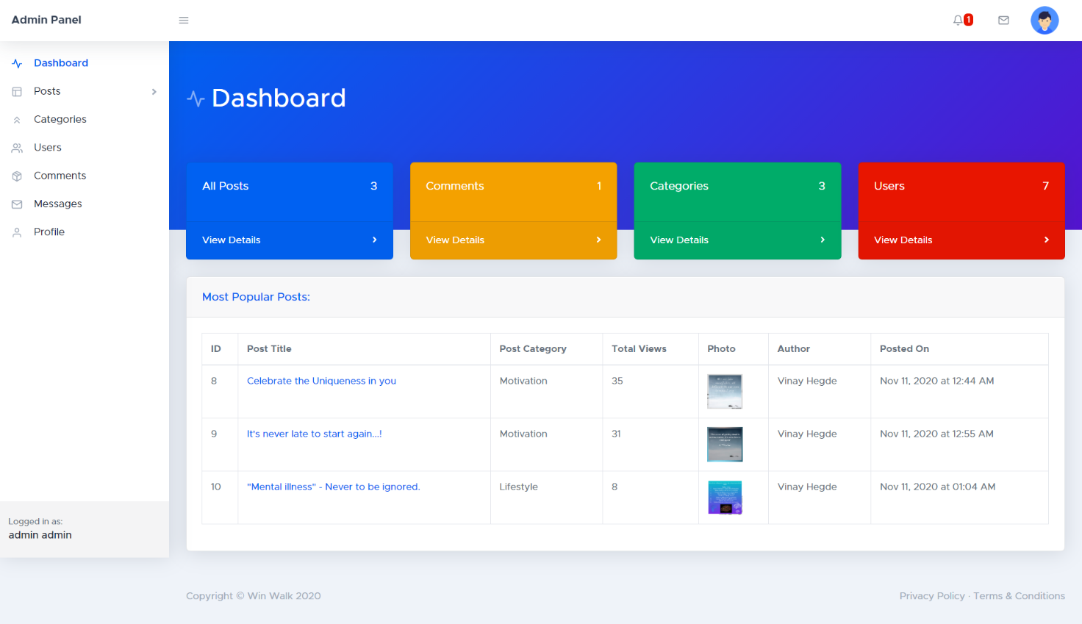

Fig 6.8 Backend Dashboard Page

Win-Walk

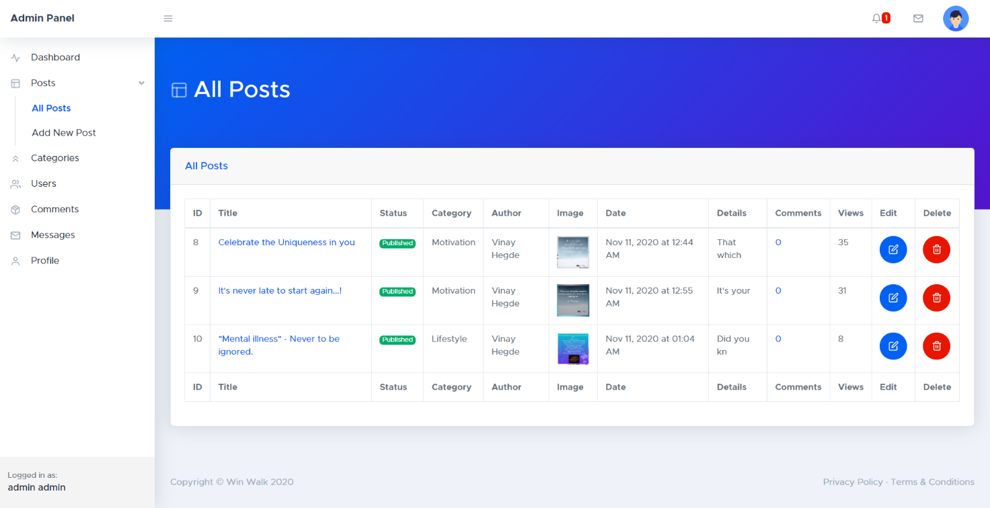

Fig 6.9 All Posts Page

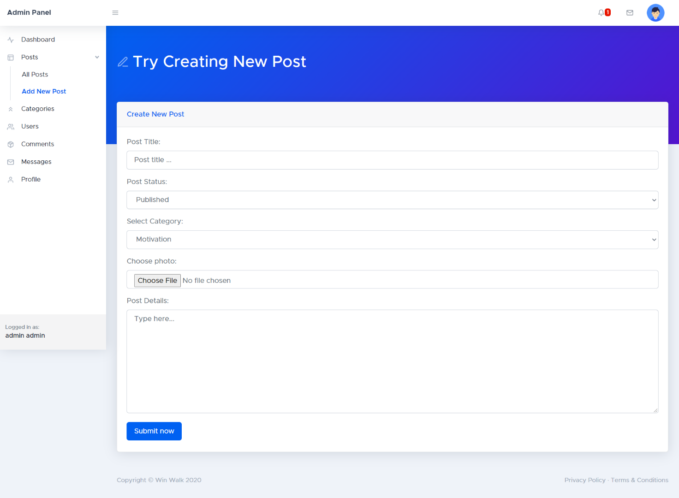

Fig 6.10 Add New Post Page

Win-Walk

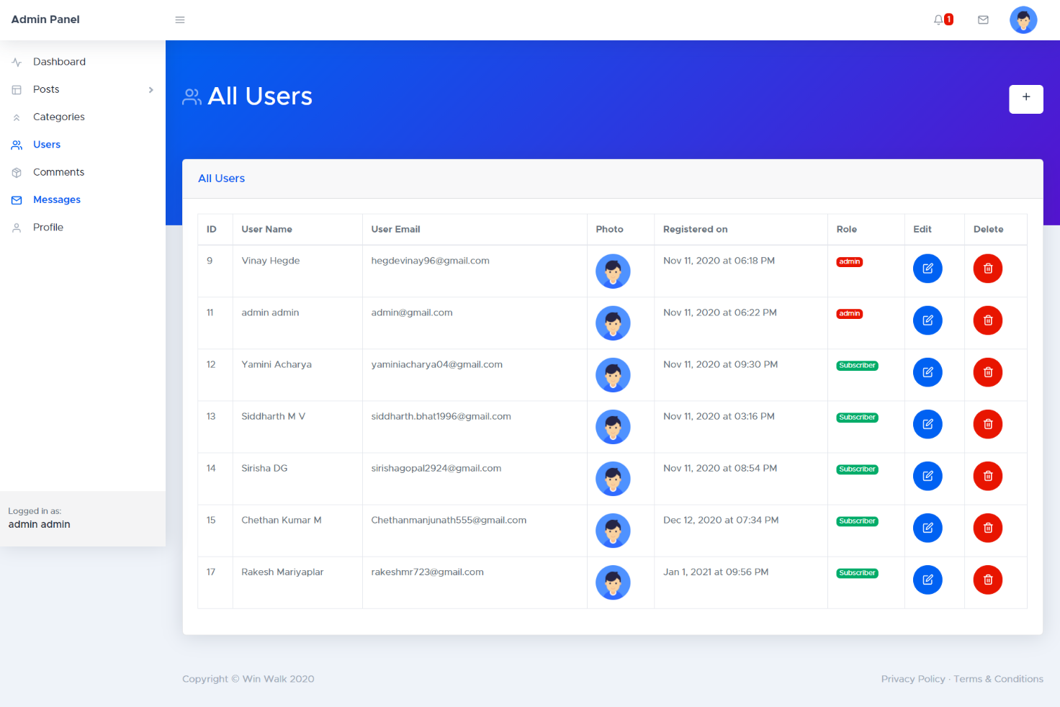

Fig 6.11 All Users Page

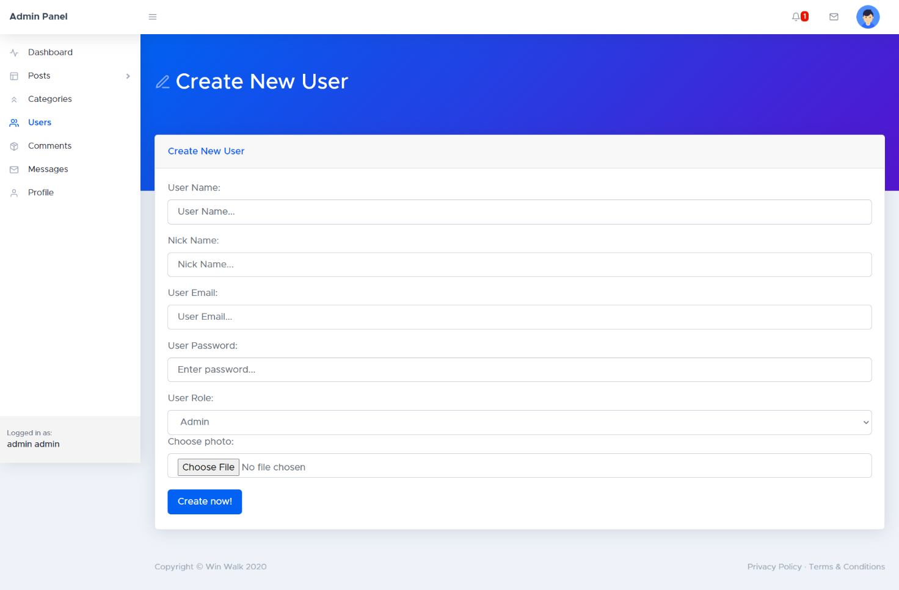

Fig 6.12 Add New User

Win-Walk

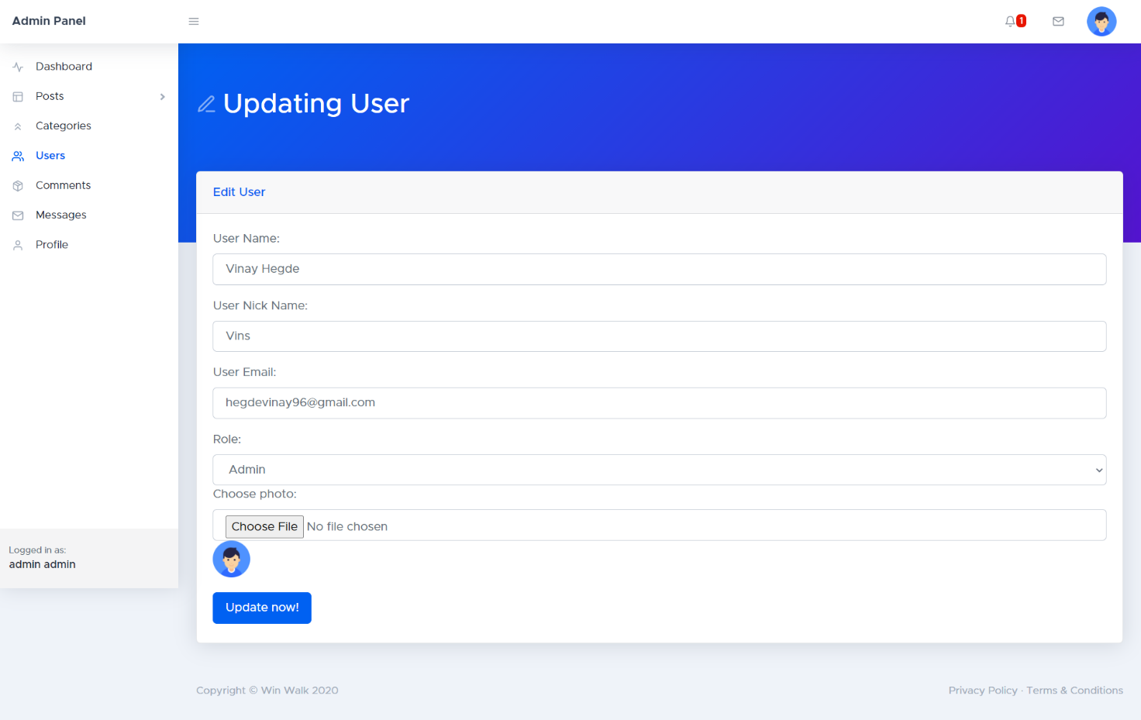

Fig 6.13 Update User

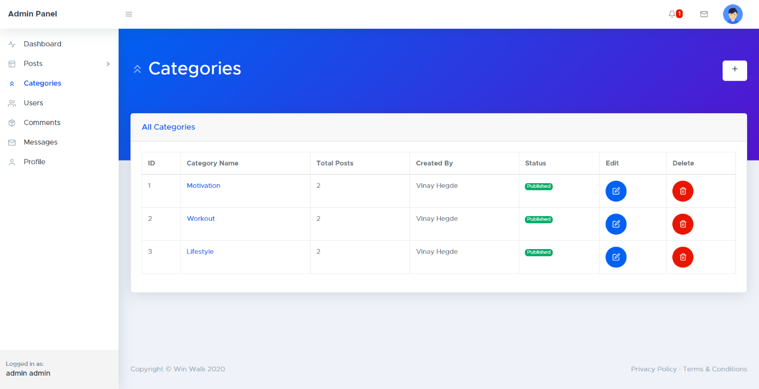

Fig 6.14 Categories

Win-Walk

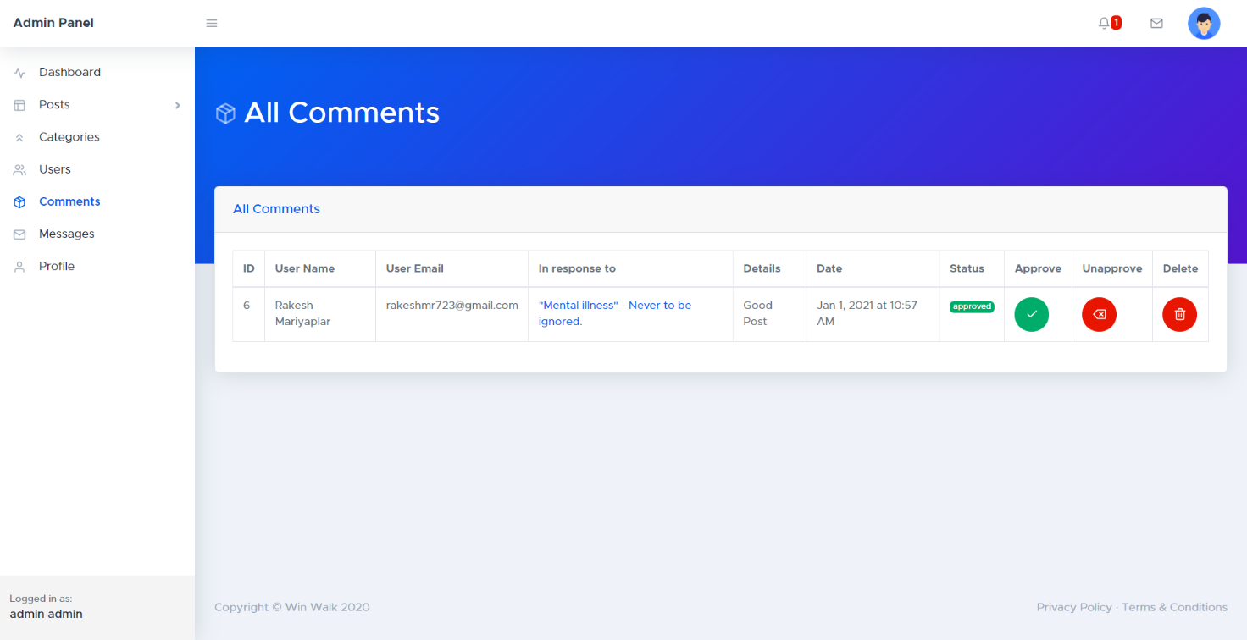

Fig 6.15 All Posts Comments

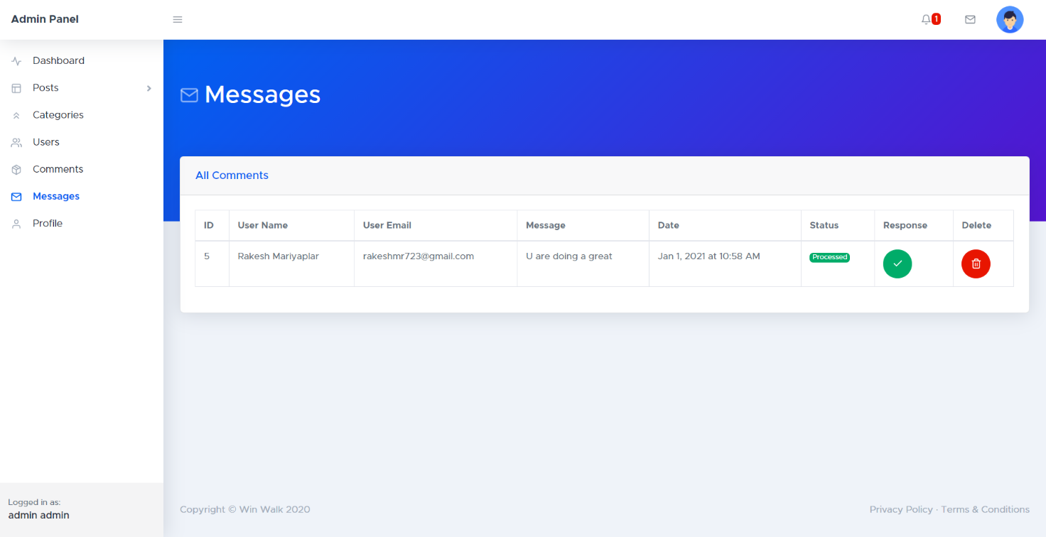

Fig 6.16 All Messages

Win-Walk

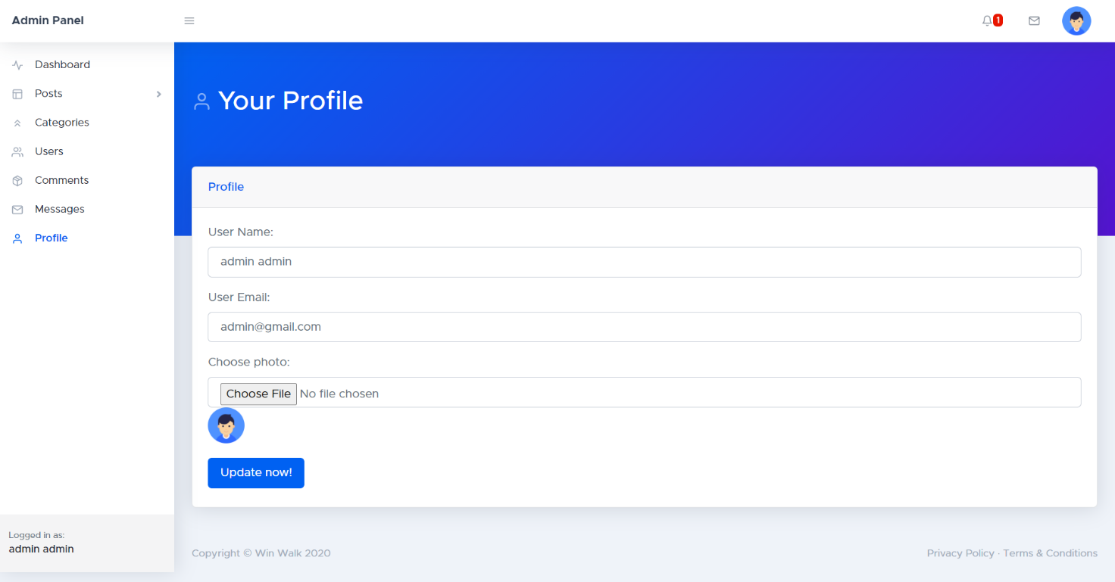

Fig 6.17 Your Profile